Exams – what to expect

This booklet will tell you all about what to expect when you sit your exams here at Forestwood School.

If you have any more questions about your exams feel free to ask Joanne Rider (Exams Officer) or Wendy Webster (Head of Centre) who will help you.

Contents

How do I know when my exams are? 3

Where will I sit my exam? 4

What do I need to bring with me to an exam? 5

What you can bring: 5

What you can’t bring: 6

Who will be in my exam? 8

What is an invigilator? 9

What an invigilator can do: 9

What an invigilator can’t do: 9

When you are in the exam room 10

What happens if there is an emergency in the exam room? 10

What is Malpractice and what does it mean? 11

What are Access Arrangements and how do I use them? 12

Reader 12

What your **reader** will do: 12

What they **cannot** do: 12

What **you** can do: 12

Scribe 13

What your **scribe** will do: 13

What they **cannot** do: 13

What **you** can do: 13

Extra Time 14

Useful ways to use your extra time: 14

Prompter 15

Your prompter can: 15

What they **cannot** do: 15

Supervised Rest Breaks 16

What happens after my exam? 17

Information sent to the Exam awarding body 18

Non-examination assessments body 19

Information for candidates 20

Candidate Confirmation 23

# How do I know when my exams are?

Joanne Rider who is our Exams Officer in school will confirm which exams you have been entered for and when they are.

You will be provided with an Exam timetable which shows you the exam dates and times.

Before you sit any exams there are certain things that you need to be aware of. These are included at the back of this booklet. You should read these and if you are unsure about anything then you should speak to Joanne Rider your Exams Officer.

What time will my exams start and finish?

We need to follow a specific timetable given to us by the Exam Awarding Bodies, so that all students take the same exam at the same time on the same day.

Exams take place in the morning and in the afternoon.

If the exam is due to start in the morning, then these will be between 09.00 and 09:30

If the exam is due to start in the afternoon, then these will be at 13.00 and 13:30

Exams last different lengths of time depending on the subject, so your exam timetable will show you how long your exam will last.

# Where will I sit my exam?

You will sit your exams in our exam room. It is the multi-faith room on treetops. If for any reason you are not able to come off ward we can set up an exam room on ward for you.

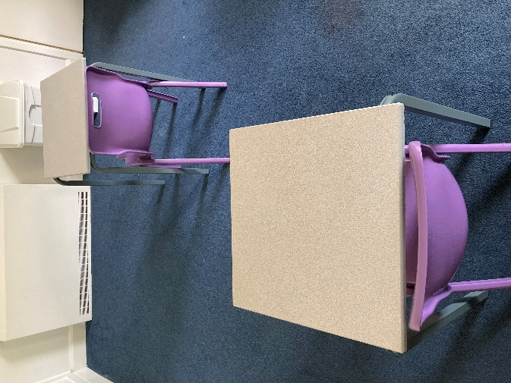

If there is more than one young person sitting an exam, the tables will be spread out so that you can sit one to a desk and have your own space. You will all face the same way and if you’d prefer to be at the front or at the back let staff know before the exam and we can try to change the seating plan to make you more comfortable.

# What do I need to bring with me to an exam?

Education staff will provide you with any equipment that you need, this can be a little different depending on the subject of your exam. We will always provide you with two pens (just in case one runs out) but you might also need things like a pencil, a ruler, a dictionary or a calculator which we will put out in the room ready for any exams that you need them for.

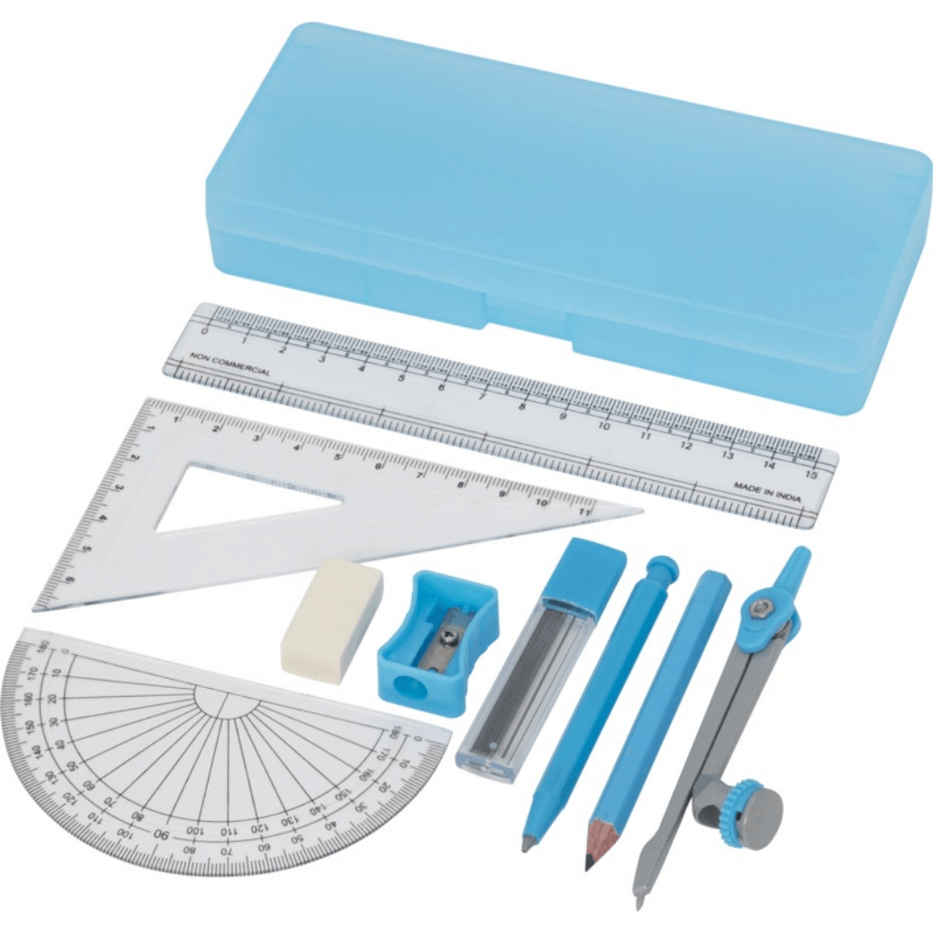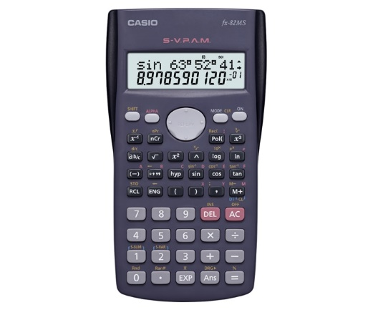

## What you can bring:

* If you have a favourite pen you can bring your own – but it must be black ink.
* You can bring a drink or a snack if it is not in any packaging. Education staff can make you a drink in a paper cup or get rid of the packaging for any snacks you might like to bring before you go into the exam room.



## What you can’t bring:

* Any books, notes, workbooks or pieces of scrap paper.

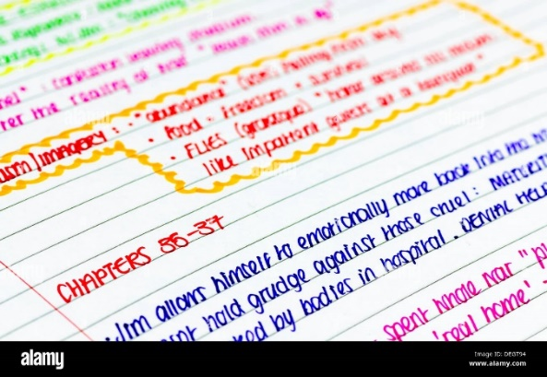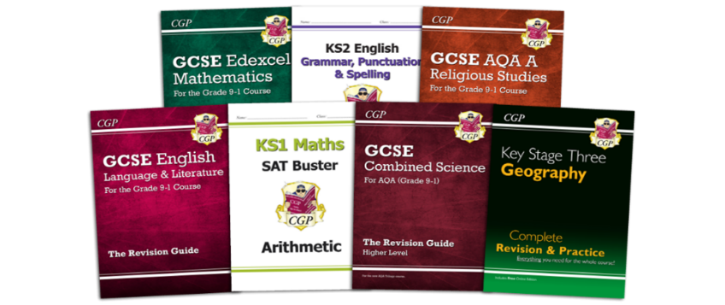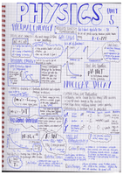

* Any electronic devices such as your mobile phone, iPod/MP3 player, iPad/tablet, smart watch or anything that you can store information on or access the internet with. We would prefer these to be left on ward, but can store them in the Education office if you need us to.
* 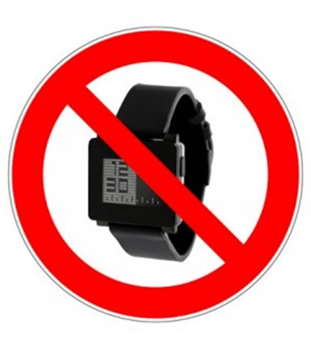A watch of any kind (don’t worry, there will be a clock in the exam room).



* Do not use correcting pens, fluid or tape (such as Tipp-Ex), erasable pens, highlighters or gel pens in your answers.

The back of this booklet has the posters, which show the rules when sitting exams – these include what you can and can’t do and what you can and can’t bring into an exam room.

These posters will also be outside the exam room as a reminder before you sit your exam.

# Who will be in my exam?

As mentioned, there might be other young people sitting exams at the same time and in the same room as you. We are careful to make sure that you feel as safe and as comfortable as possible during exams and will always make sure that you don’t have to sit an exam in a room with a peer that you don’t get along with, and that our young people will not distract or disrupt one another.

Because we are such a small school, you will most often be in a room on your own but we can’t guarantee this because it depends on how many young people are sitting exams with us.

Education staff will invigilate your exam (more about what that means on the next page) and depending on your level of observations, there may need to be ward staff in the room too.

## What is an invigilator?

An invigilator is someone who will be with you in every exam. They are there to make sure that you have everything that you need, that you follow the rules, and that you know when to start and when to finish your exam.

Education staff are usually willing to help you in any way that they can, but during an exam their role is quite different and there are rules that they have to follow.

You must listen and follow the instructions of the invigilator at all times in the exam room.

## What an invigilator can do:

* Get any additional equipment that you need during the exam (for example a ruler or tracing paper).
* Answer questions about the exam process (but not the actual exam questions).
* Look after you if you are feeling unwell.
* Arrange for you to have a break or use the bathroom during your exam.

## What an invigilator can’t do:

* Help you to answer any of the questions on your exam paper.
* Tell you how to spell words.
* Explain or re-word questions for you.
* Tell you which questions to answer.

# When you are in the exam room

You mustn’t talk to other young people in the exam room or disturb them so that everyone has the same opportunity to do their best.

There will be a whiteboard, which will have information about your exam on it, such as the subject, start time, date etc.

The invigilator will give you a card with your centre number, candidate number, and a list of any exam access arrangements that you have on it. Usually the centre number would be on a whiteboard but because we have students from lots of different schools not everyone in the exam room will have the same centre number.

You must not open the question paper or write on the front until the invigilator tells you can do so.

# What happens if there is an emergency in the exam room?

If there is an emergency, you should let the invigilator(s) in your exam room know.

The invigilator will then tell you what is going to happen – you should always follow the instructions of the invigilator – they will have a radio to call for help if needed.

# What is Malpractice and what does it mean?

* You might know malpractice as ‘cheating’
* It means that you or the school have not followed the rules of an exam
* If you or the school don’t follow the rules then it may mean that you are disqualified from the exam and other exams that you might have already sat.
* Some common things which are classed as malpractice are:-
  + Bringing notes or books into the exam room when they are not allowed
  + Bringing a mobile phone or watch into the exam room
  + Trying to copy answers from other young people or telling other young people answers
  + Not following the instructions the invigilator gives you in an exam

Your Exam Officer Joanne Rider will give you some information regarding malpractice, as it is important you know the rules so that you can follow them

# What are Access Arrangements and how do I use them?

There are different kinds of Exam Access Arrangements that can be used to make sure that you have a fair chance in exams. Access arrangements must be applied for **before** exams by either your community school or the Phoenix School. The types most used in our school are listed below.

## Reader

### What your **reader** will do:

* **read** the instructions of the question paper and questions, but **must not** explain or clarify
* read **numbers printed in figures as words** (e.g. 356 would be read as three hundred and fifty six, but when reading the number will also point to the number on the question paper)
* Read things back to you / read things again **if you ask them to**
* Read out what you have written **if you ask them to**
* Point to diagrams and pictures and read out information linked to them

### What they **cannot** do:

* **Read the questions in an English reading paper** – they can only read out the instructions for this exam
* **Explain the meanings** of words or questions in any exam
* **Tell you which questions to answer**, or **when to move on** to the next question
* **Spell things** for you to write down
* **Explain** what **pictures or diagrams** mean, or what they show

### What **you** can do:

* You can **ask for things to be read to you as many times as you need**
* You can **ask your reader to read out what you have written down in your answer** so that you can check it
* You can **ask the reader to spell out a word** from the exam paper

## Scribe

### What your **scribe** will do:

* **write or type** accurately, and at a reasonable speed, what you have said
* draw or add to **maps, diagrams and graphs** when you tell them to
* only **correct or change** things that they have written if you ask them to
* **read aloud what they have written** only if you ask them to

### What they **cannot** do:

* **Tell you which questions to answer**, or **when to move on** to the next question
* **Spell things** for you
* **Explain** what **pictures or diagrams** mean, or what they show
* **Add anything or change anything** in what they have written unless you tell them to.

### What **you** can do:

* You can **ask for your answer to be read out to you** so that you can check it**.**
* You can **ask your scribe to add or correct things** once they have been written down
* You can **spell out** subject specific words, and tell the scribe where to add punctuation.

## Extra Time

## 

### Useful ways to use your extra time:

* Use it as reading and preparation time, and to check your answers at the end
* Divide the time by the number of questions that you have to answer, and add a bit onto every question – for example:
* The exam is 2 hours, with 30 minutes to read the text and 1 ½ hours to answer 3 questions
* Your extra time will be 30 minutes (25%), so add 7 ½ minutes onto your reading time, and onto the time that you have to answer each of the 3 questions
* Use the extra time on the questions that have the most marks attached to them.

For example if your paper has two 12 mark questions, add 10 minutes extra onto each of these questions, and use the remaining ten minutes as time to check through your answers at the end.

* However you decide to use your extra time, it helps to plan it, and write down the timings for when you get into the exam – perhaps like this:

History exam – 2 hours

5 questions

Extra time 25% = 30 minutes.

Timings:

Starts at 2:00

Reading time: 2:00-2:05

Question 1: 2:05- 2:34

Question 2: 2:34 – 3: 03

Question 3: 3:03- 3:32

Question 4: 3:32-4.01

Question 5: 4:01-4:30

Exam ends: 4:30

## Prompter

### Your prompter can:

* Use **voice** or **visual** prompts to keep you focussed or tell you how much time you have left
* Tap on the desk (or your arm/shoulder if you prefer) to refocus you, and/or to remind you to move onto the next question
* Use **your name** out loud to get your attention

### What they **cannot** do:

* **Tell you which questions to answer**, or **the order to answer questions in.**
* **Spell or read** things for you
* **Explain** what words, pictures or diagrams mean, or what they show.
* **Give you any help** other than the prompts described above.

## Supervised Rest Breaks

Supervised Rest Breaks are something that most of our students are entitled to. They are designed to take some of the pressure and anxiety away from you during the exam, so that if you are starting to struggle to concentrate or just need a break you can take some time out without missing out on your exam time.

If you feel as though you need to take a break, ask your invigilator and they will ‘stop the clock’. They will time how long the break took and add it on so that you get the whole of your exam time.

A break can last for as little or as long as you need it to, and you can have as many breaks as you need during an exam.

There are some rules that you need to follow during the breaks:

* You will still be under exam conditions and will need an invigilator with you at all times.
* You will not be allowed into your bed space and must use the communal toilets on ward.
* You will not be allowed access to your mobile phone or any other device that allows you to contact others.
* You will not be allowed to speak to anyone about the exam or ask them exam related questions.
* You will not be allowed to read any notes or any textbooks that you have.
* You will be allowed to have a drink or some food.
* Sometimes it is a good idea to have a walk, stretch your legs and go to an outdoor space for some fresh air.
* When going for or coming back from a break, please be as quiet as you can so that you do not disturb others that are doing exams.

# What happens after my exam?

After your exam, the invigilator will check that you have completed all of the information on the front of your exam (e.g. your name, signature and candidate number) before collecting in the papers. You will then be allowed to leave the exam room and collect your phone from the Education office (if you didn’t leave it on ward). You can chat to your subject teacher about how you felt it went, and education staff will support you if the exam has left you feeling worried.

Results can take a long time to come back, so be patient! When your final results are ready, you (or a parent/guardian/the Education Officer) can call up your community school and have them sent to you. If you don’t have a community school, Joanne Rider from education will give your results to you directly.

Your community school will receive your certificate and distribute this/these to you. If you don’t have a community school, then Joanne Rider will arrange for this/these to be sent to you.

You have the right to appeal or make a complaint if you think that the school did not follow the correct procedures for any of your exams. If you have any questions or want some information on how to make an appeal or complaint then speak to Joanne Rider or your Head Teacher and they will provide you with the information. If you don’t feel comfortable speaking to your Head Teacher or Exams Officer, then you can speak to a parent/carer or a member of our hospital staff to support you with this.

# Information sent to the Exam awarding body

* When you are entered for an exam, your school needs to send information about you to the awarding body
* We need to make sure you know what is sent and why, so your Exams Officer Joanne Rider has included the ‘Information for Candidates’ at the back of this booklet so you have all the information.
* Joanne Rider will go through this with you, and if you have any questions let her know.

# Non-examination assessments body

* If you have any exams which mean you must complete coursework (non-examination assessment) then your subject teacher will tell you all the information you need to know about this.
* They will tell you:-
  + When the assessment will be
  + If you need to meet any deadlines and what they are
  + How your work will be marked/assessed
  + When you will know what your centre assessed marks
  + When work is externally marked or assessed

# Information for candidates

**The JCQ information for candidates documents**

All documents can be found at this website:-

<https://www.jcq.org.uk/exams-office/information-for-candidates-documents>

Your Exams Officer will print off the documents for you to read and go through these with you to make sure you understand them.

Information for candidates

Below are the Exam Room posters. You should read these to make sure you are aware of what you can and can’t do and bring into the exam room.

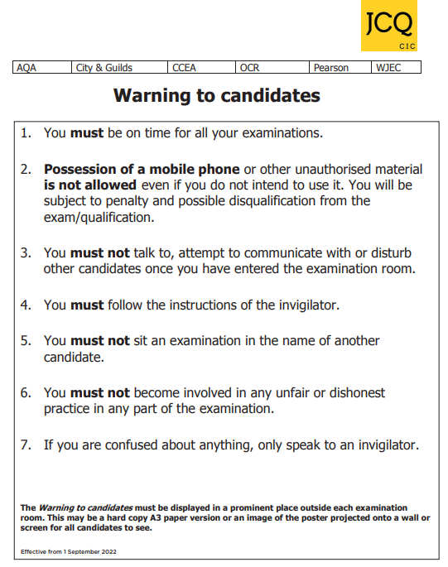



Candidate Confirmation

To confirm you have received, read and understood the contents of this guide, please sign and date the tear-off slip below and return to Joanne Rider or Wendy Webster.

If there is anything you do not understand, you should ask Joanne Rider or Wendy Webster for clarification

**Candidate Exam Guide**

**NAME**: …………………………………. **Date I received the handbook:** ………………………..

**I have read the contents**

**I understand** (Tick all of the boxes that apply)

* What constitutes malpractice in examinations/assessments
* What my personal data is used for by awarding bodies
* What I can and can’t do in the exam room

**I have read and understand the 2022-2023 JCQ information for candidates documents** as they relate to the qualifications I am taking (Tick all of the boxes that apply)

* Coursework
* Non-examination assessments
* On-screen tests
* Privacy Notice
* Social media
* Written exams

By signing here, I am confirming all of the above

**Candidate Signature**: …………………………………………………

**Date of signature**: ………………………